Sports Tournament Management

1. Creating the tables.

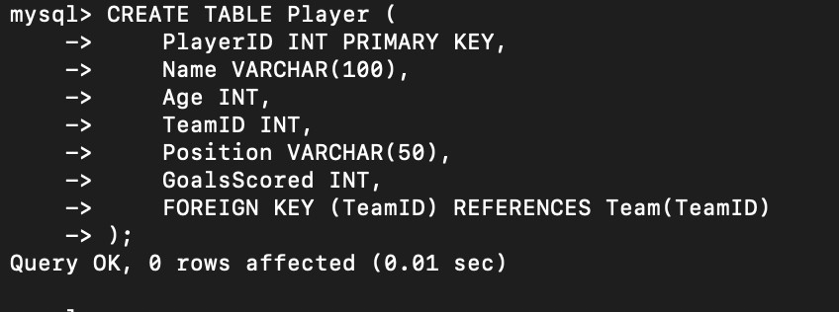

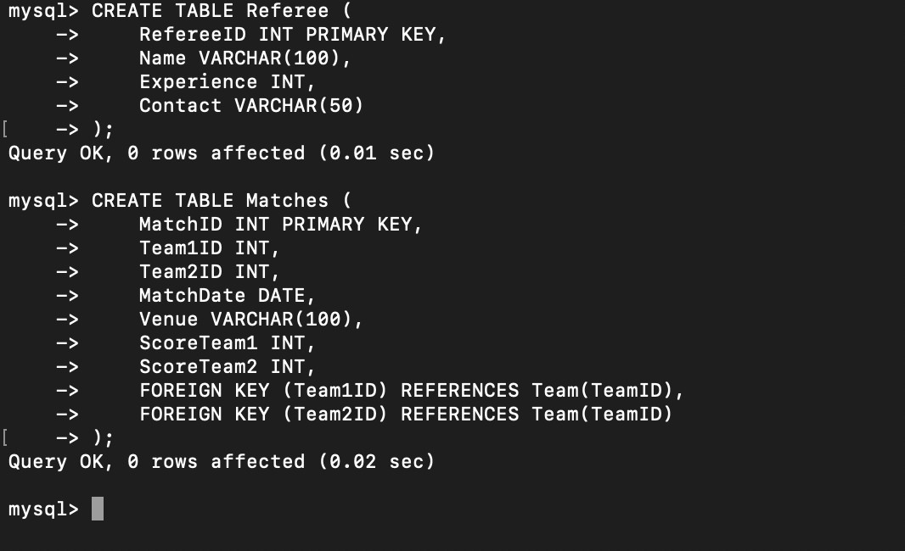

1. Inserting sample data.

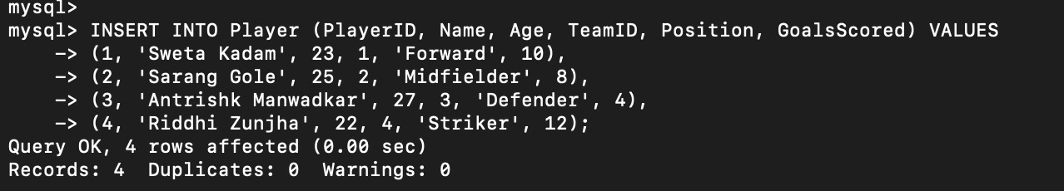

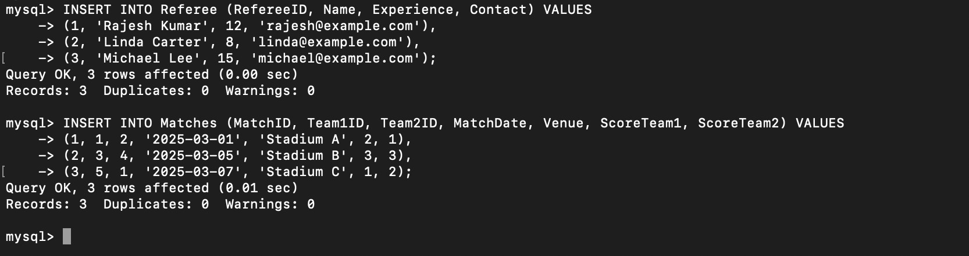

1. Retrieve the top 5 highest-ranked teams.

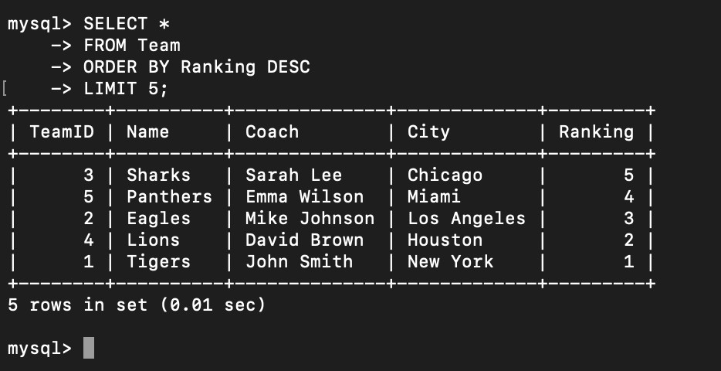

1. Find the player with the most goals scored.

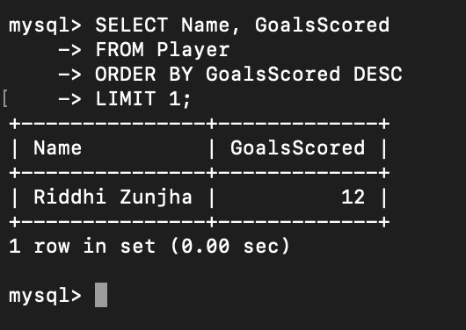

1. Display match results from the last week.

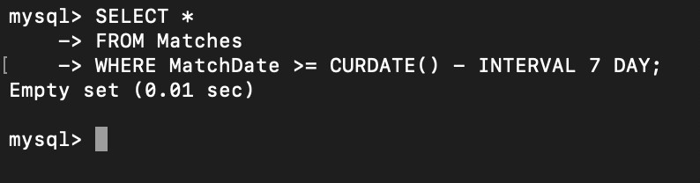

1. Retrieve referees with more than 10 years of experience.

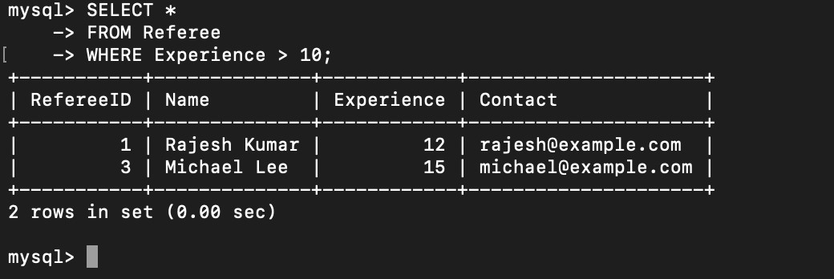

1. Find teams that have won more than 5 matches.

